1. Prior Density Distribution

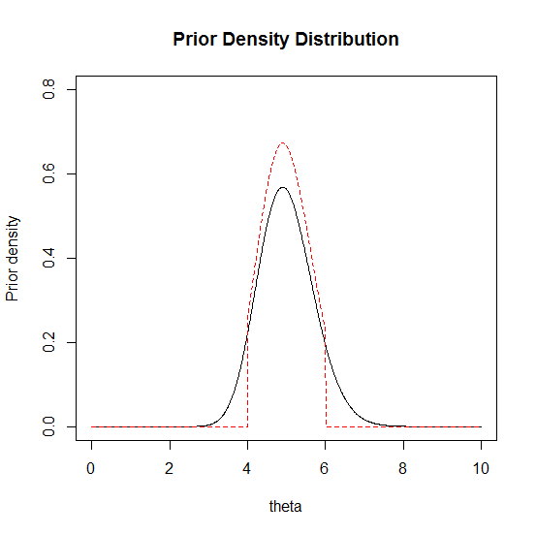

1. Posterior Density Distribution

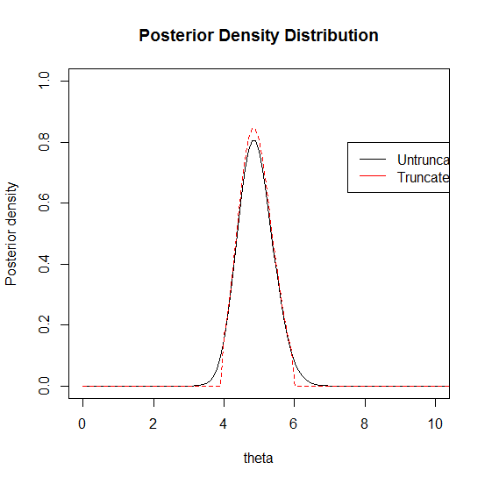

95% Credible Interval for Untruncated is ***1.938532***; 95% Credible Interval for Truncated is ***1.667678.***

The probability density distribution become more concentrated as theta is being truncated.

1. Another Data Set

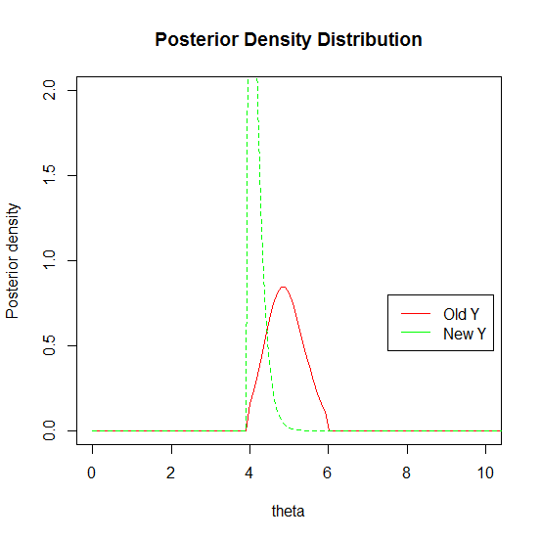

95% Credible Interval for New Truncated Posterior is ***0.6417365***

We can see, the posterior under new Y=(2,1,0,4,1,1,0,1,1,4). Become almost a peak at 4, which is due to the reason that there’s only two 4 affecting the posterior distribution.

Code:

##########Prior################

theta=seq(0,10,length=1000);alpha=50;beta=1/0.1;

y <- c(2, 1, 9, 4, 3, 3, 7, 7, 5, 7);n=length(y)

a=4;b=6

prior1 <- dgamma(theta,alpha,beta)

prior2 <- function(theta,alpha,beta,a,b){

z=dgamma(theta,alpha,beta)*as.numeric(theta > a & theta < b)/(pgamma(b,alpha,beta)-pgamma(a,alpha,beta))

return(z)

}

plot(theta,prior1,type="l",xlab="theta",ylab="Prior density",ylim=c(0,0.8))

lines(theta,prior2(theta,alpha,beta,a,b),col="red",lty=2)

title("Prior Density Distribution")

##########Posterior ,Data set 1################

theta=seq(0,100,length=1000);alpha=50;beta=1/0.1;

y <- c(2, 1, 9, 4, 3, 3, 7, 7, 5, 7);

y.new <- c(2,1,0,4,1,1,0,1,1,4)

n=length(y);n.new=length(y.new)

a=4;b=6

prior1 <- dgamma(theta,alpha,beta)

prior2 <- function(theta,alpha,beta,a,b){

z=dgamma(theta,alpha,beta)*as.numeric(theta > a & theta < b)/(pgamma(b,alpha,beta)-pgamma(a,alpha,beta))

return(z)}

#plot(theta,prior1,type="l",xlab="theta",ylab="Prior density",ylim=c(0,0.8))

#lines(theta,prior2(theta,alpha,beta,a,b),col="red",lty=2)

#title("Prior Density Distribution")

posterior1 <- dgamma(theta,alpha+sum(y),beta+n);

posterior2 <- dgamma(theta,alpha+sum(y),beta+n)*as.numeric(theta > a & theta < b)/(pgamma(b,alpha+sum(y),beta+n)-pgamma(a,alpha+sum(y),beta+n))

posterior3 <- dgamma(theta,alpha+sum(y.new),beta+n.new)*as.numeric(theta > a & theta < b)/(pgamma(b,alpha+sum(y.new),beta+n.new)-pgamma(a,alpha+sum(y.new),beta+n.new))

truncated.inverse.cdf <- function(p,theta,alpha,beta,yyyy){

F.a=pgamma(4,alpha+sum(yyyy),beta+length(yyyy))

F.b=pgamma(6,alpha+sum(yyyy),beta+length(yyyy))

z=qgamma((F.b-F.a)*p+F.a,alpha+sum(yyyy),beta+length(yyyy))

return(z)

}

lower1 <- qgamma(.025,alpha+sum(y),beta+n)

upper1 <- qgamma(.975,alpha+sum(y),beta+n)

length1 <- upper1-lower1

lower2 <- truncated.inverse.cdf(.025,theta,alpha,beta,y)

upper2 <- truncated.inverse.cdf(.975,theta,alpha,beta,y)

length2 <- upper2-lower2

lower3 <- truncated.inverse.cdf(.025,theta,alpha,beta,y.new)

upper3 <- truncated.inverse.cdf(.975,theta,alpha,beta,y.new)

length3 <- upper3-lower3

plot(theta,posterior1,,type="l",xlab="theta",ylab="Posterior density",ylim=c(0,1),xlim=c(0,10))

lines(theta,posterior2,col="red",lty=2)

legend(7.5,0.8,c("Untruncated","Truncated"),lty=c(1,1),col=c("black","red"))

title("Posterior Density Distribution")

print(length1)

print(length2)

##########Posterior , Data set 2################

theta=seq(0,100,length=1000);alpha=50;beta=1/0.1;

y <- c(2, 1, 9, 4, 3, 3, 7, 7, 5, 7);

y.new <- c(2,1,0,4,1,1,0,1,1,4)

n=length(y);n.new=length(y.new)

a=4;b=6

prior1 <- dgamma(theta,alpha,beta)

prior2 <- function(theta,alpha,beta,a,b){

z=dgamma(theta,alpha,beta)*as.numeric(theta > a & theta < b)/(pgamma(b,alpha,beta)-pgamma(a,alpha,beta))

return(z)}

#plot(theta,prior1,type="l",xlab="theta",ylab="Prior density",ylim=c(0,0.8))

#lines(theta,prior2(theta,alpha,beta,a,b),col="red",lty=2)

#title("Prior Density Distribution")

posterior1 <- dgamma(theta,alpha+sum(y.new),beta+n);

posterior2 <- dgamma(theta,alpha+sum(y),beta+n)*as.numeric(theta > a & theta < b)/(pgamma(b,alpha+sum(y),beta+n)-pgamma(a,alpha+sum(y),beta+n))

posterior3 <- dgamma(theta,alpha+sum(y.new),beta+n.new)*as.numeric(theta > a & theta < b)/(pgamma(b,alpha+sum(y.new),beta+n.new)-pgamma(a,alpha+sum(y.new),beta+n.new))

truncated.inverse.cdf <- function(p,theta,alpha,beta,yyyy){

F.a=pgamma(4,alpha+sum(yyyy),beta+length(yyyy))

F.b=pgamma(6,alpha+sum(yyyy),beta+length(yyyy))

z=qgamma((F.b-F.a)*p+F.a,alpha+sum(yyyy),beta+length(yyyy))

return(z)

}

lower1 <- qgamma(.025,alpha+sum(y),beta+n)

upper1 <- qgamma(.975,alpha+sum(y),beta+n)

length1 <- upper1-lower1

lower2 <- truncated.inverse.cdf(.025,theta,alpha,beta,y)

upper2 <- truncated.inverse.cdf(.975,theta,alpha,beta,y)

length2 <- upper2-lower2

lower3 <- truncated.inverse.cdf(.025,theta,alpha,beta,y.new)

upper3 <- truncated.inverse.cdf(.975,theta,alpha,beta,y.new)

length3 <- upper3-lower3

plot(theta,posterior2,col="red",type="l",xlab="theta",ylab="Posterior density",ylim=c(0,2),xlim=c(0,10))

lines(theta,posterior3,col="green",lty=2)

legend(7.5,0.8,c("Old Y","New Y"),lty=c(1,1),col=c("red","green"))

title("Posterior Density Distribution")

print(length2)

print(length3)